Creating a s3 bucket

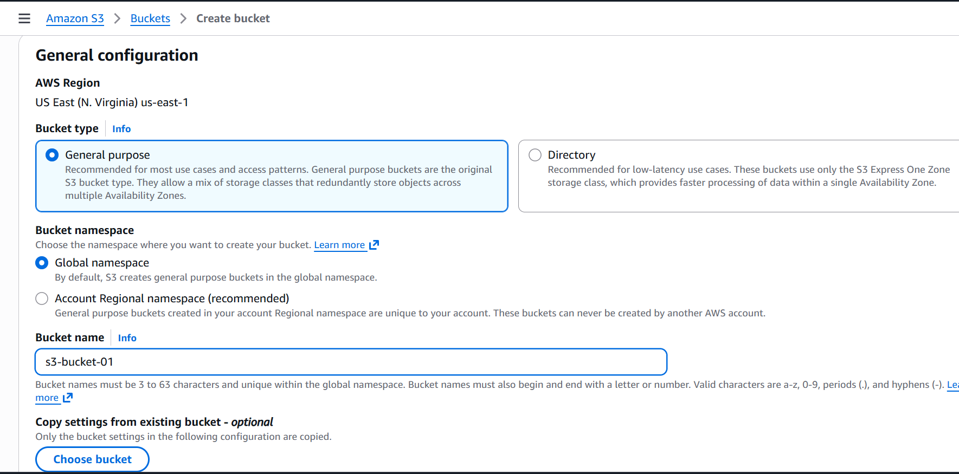

Creating a new bucket with s3-bucket-01 as name
And uploading files to the bucket
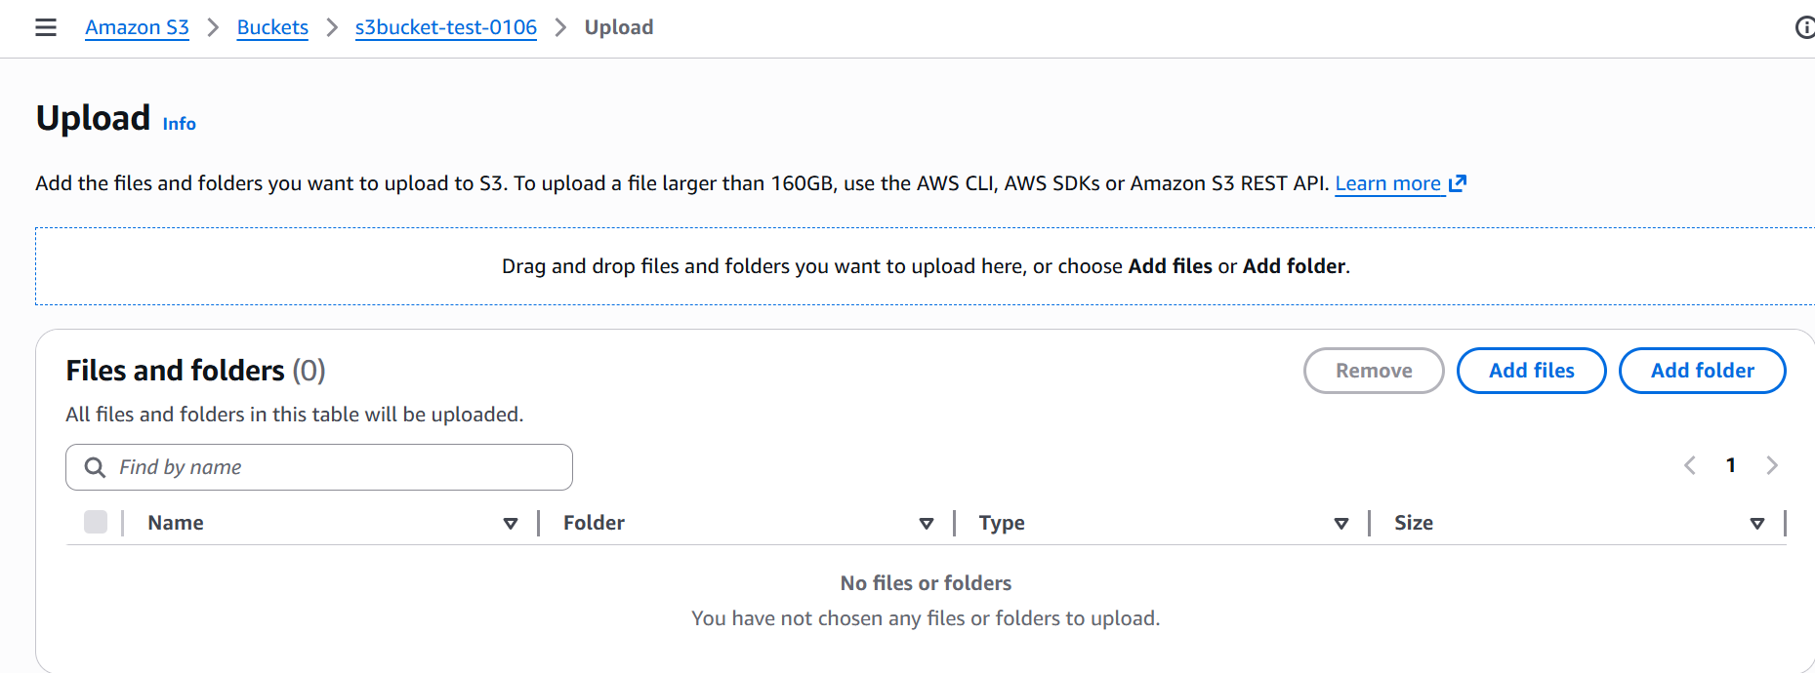

Files has been uploaded
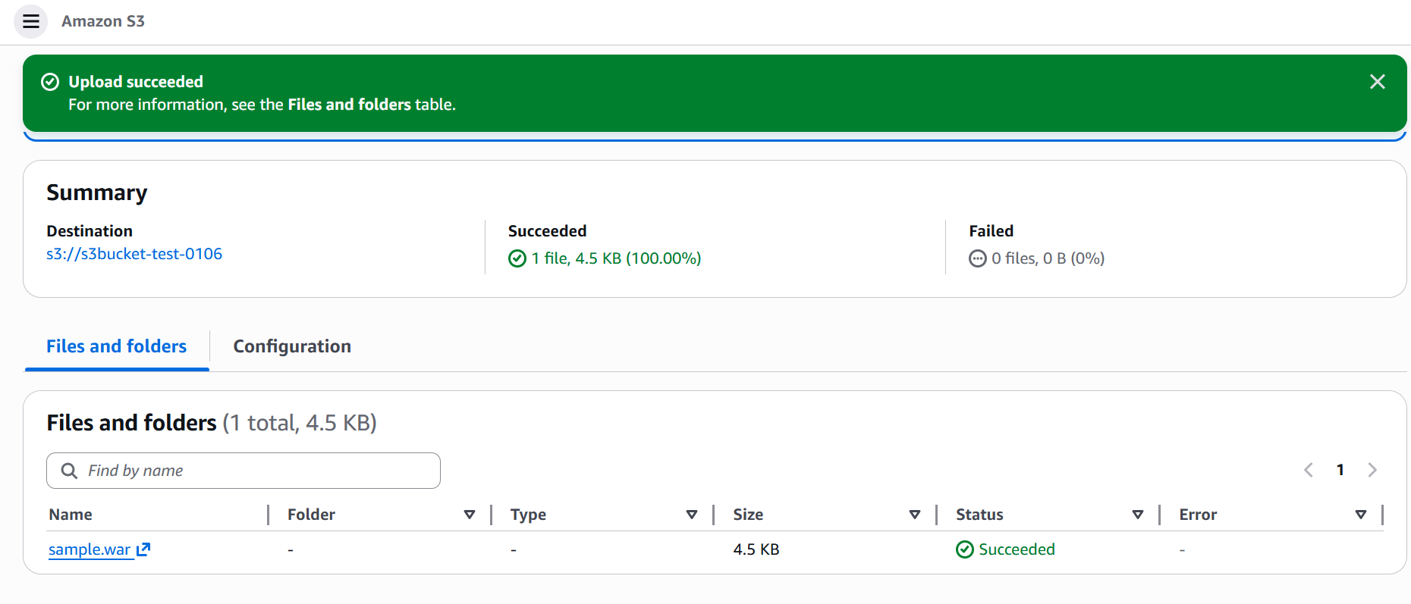

Deploy a static website in the S3 bucket

Creating a new index.html file and error.html file in desktop and uploading the doc to s3 from there the static website should be deployed

In properties search for website hosting
It will help us to deploy using .HTML file
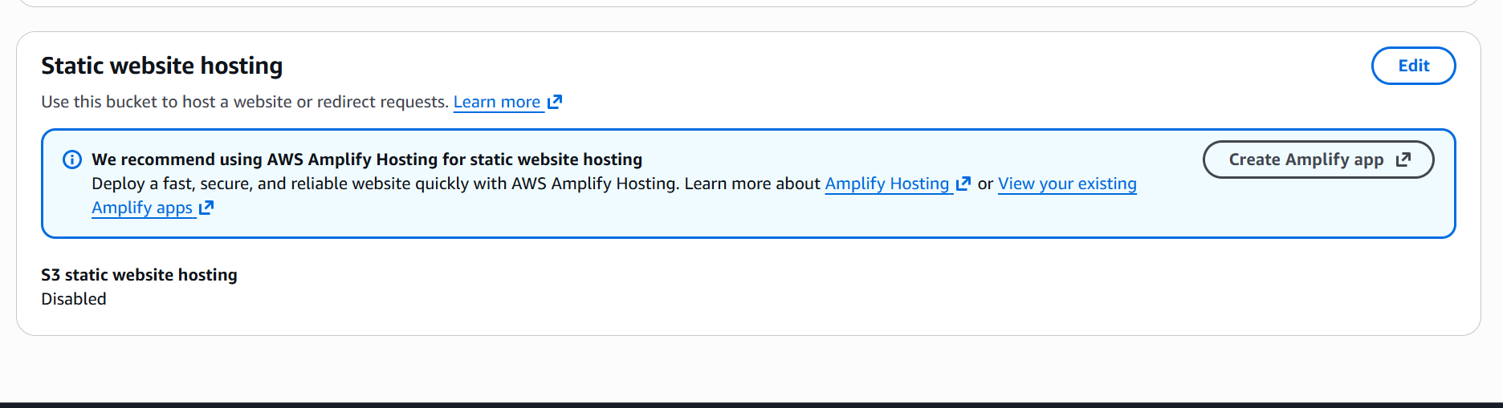

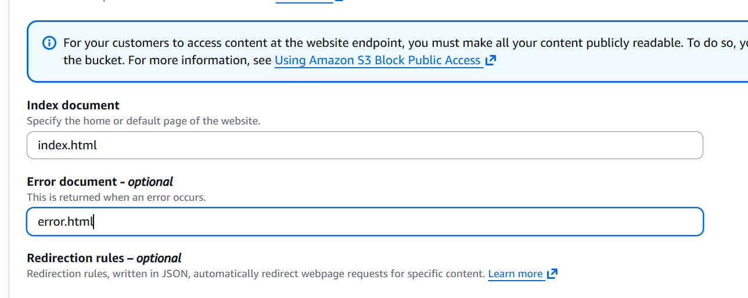

I have made changes in website hosting and I need to give names as per the .html doc that is to be uploaded but the format should be in.html
Now I will be uploading both thes text documents that is to be deployed with the same name
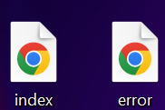

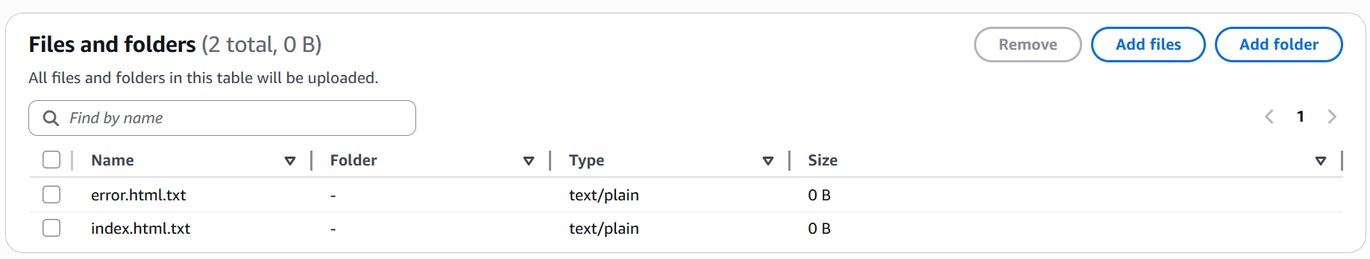

We need to enable acl to make objects public and deploy the .html

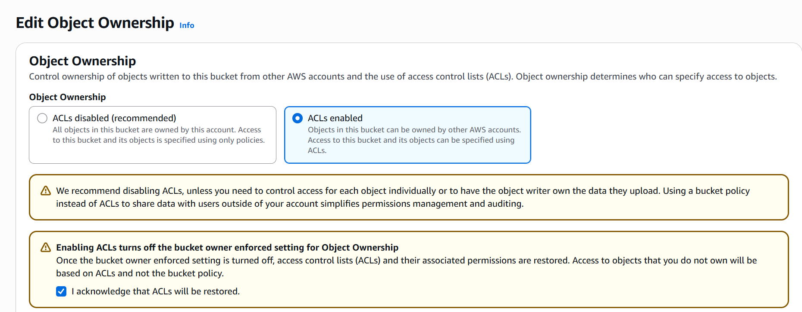

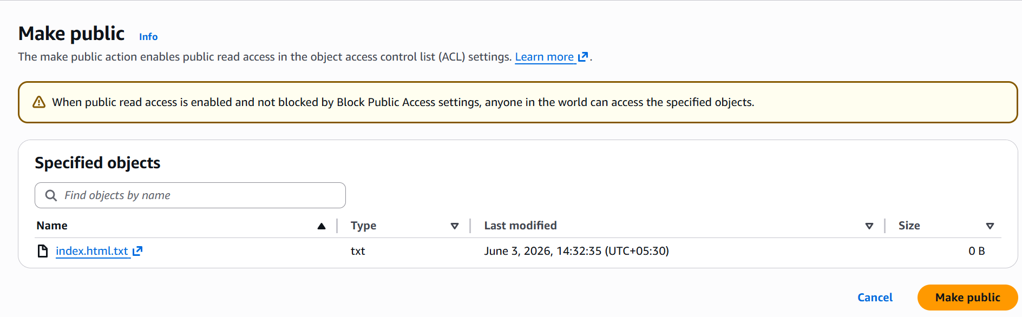

Now we can I have deployed a static website from s3
With just .html file

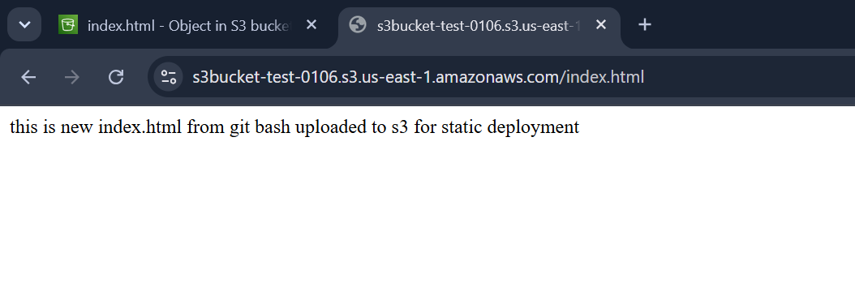
Now I hahve deleted index.html file from s3 and now the contents in error.html file displays in the same browser automatically when refreshed
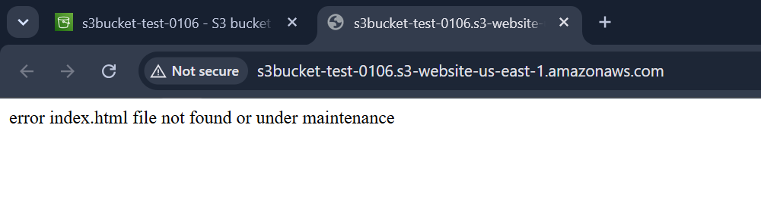

Enable cross-region replication on S3 buckets

Cross Region Replication is a feature that replicates the data from one bucket to another bucket which could be in a different region

i want to copy my files from one bucket to another buket
We will be configuring this in aws console but we use AWS CLI to push these files to another bucket

First creating a new bucket in different region

And we need to enable versioning to overcome the file replacements with same names

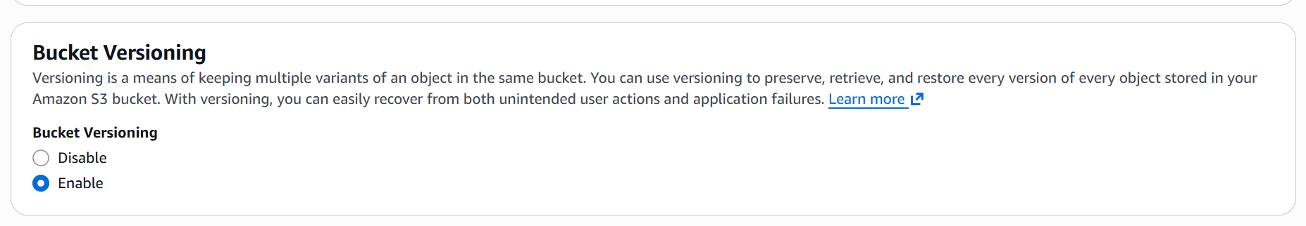
Here I have created two buckets in different regions
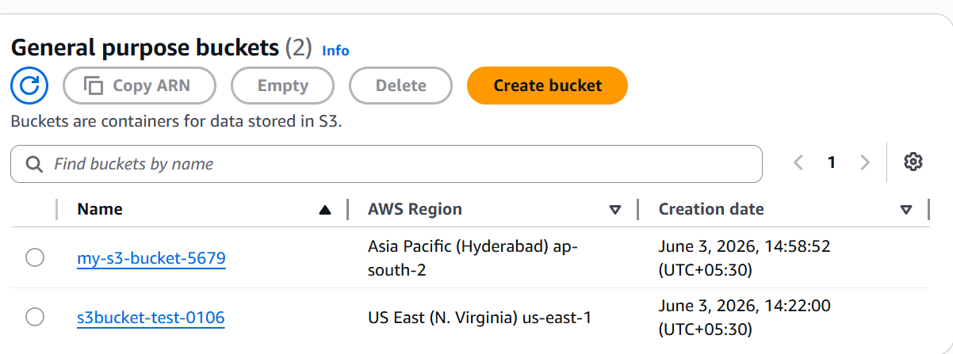

Now I will create replication rule for buckets from the host bucket

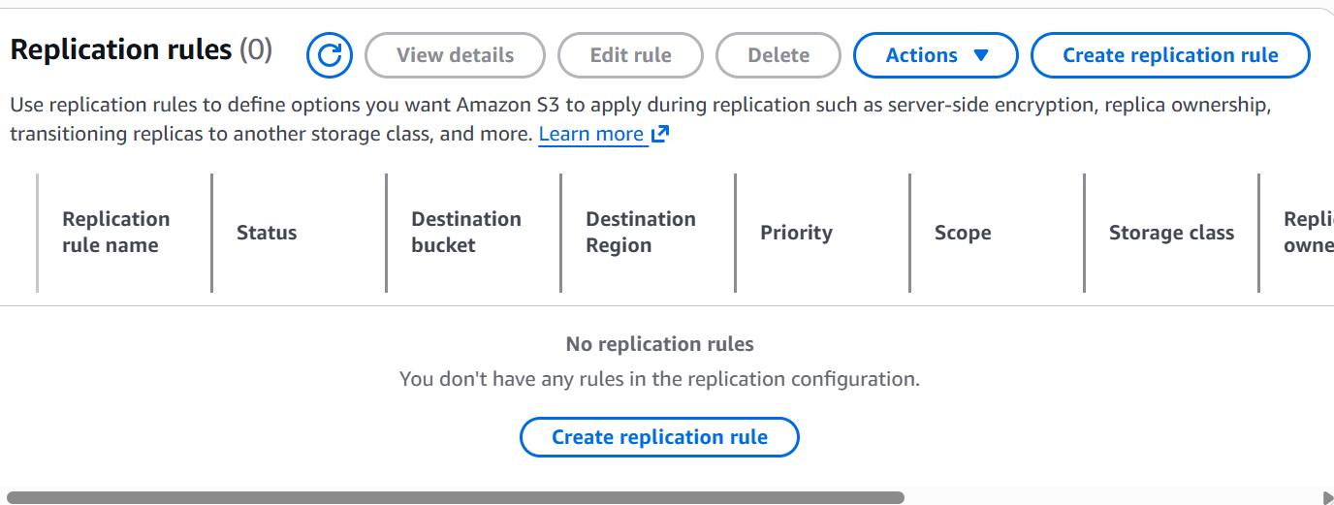

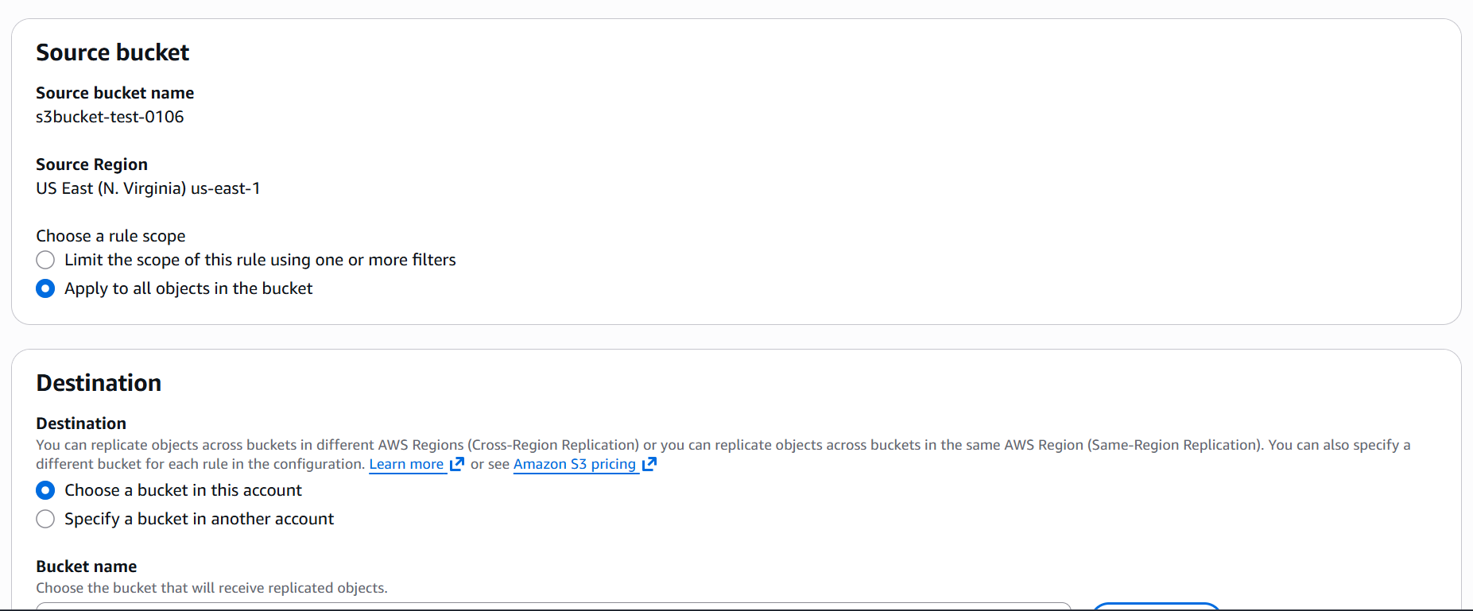
Here when I press create a new rule it automatically creates a new rule from the above mentioned replication name from the configurations itself

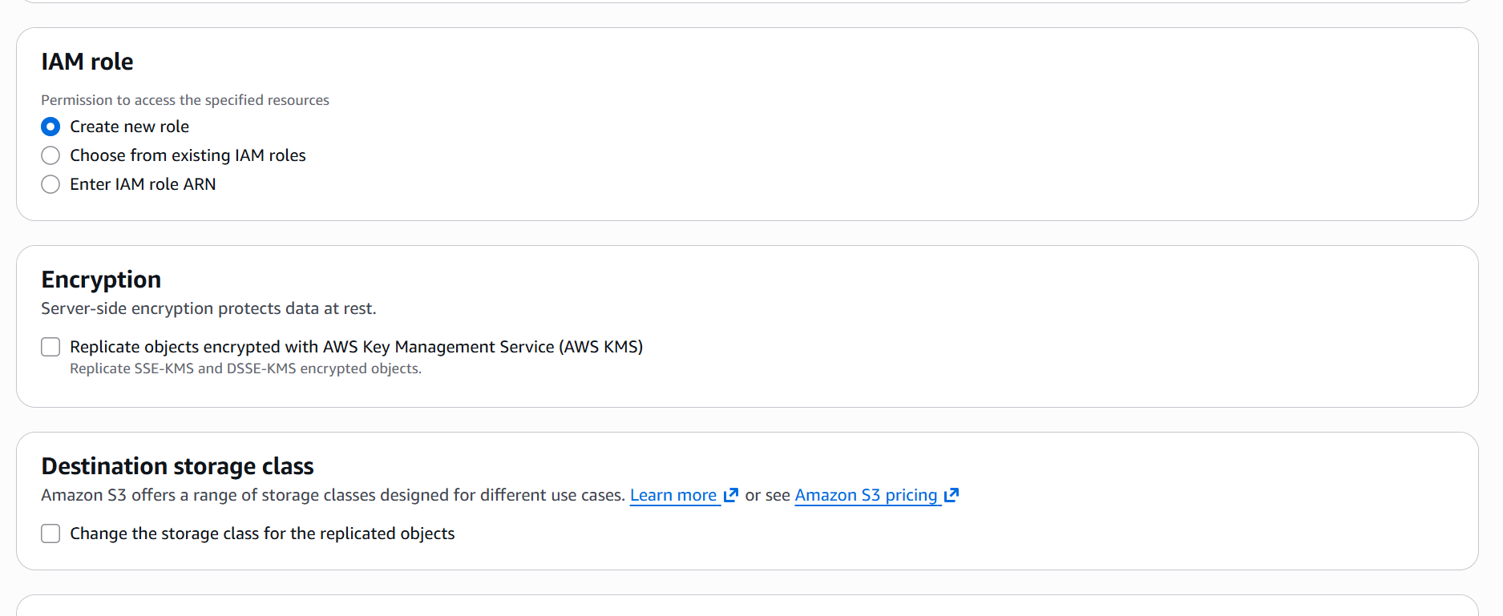

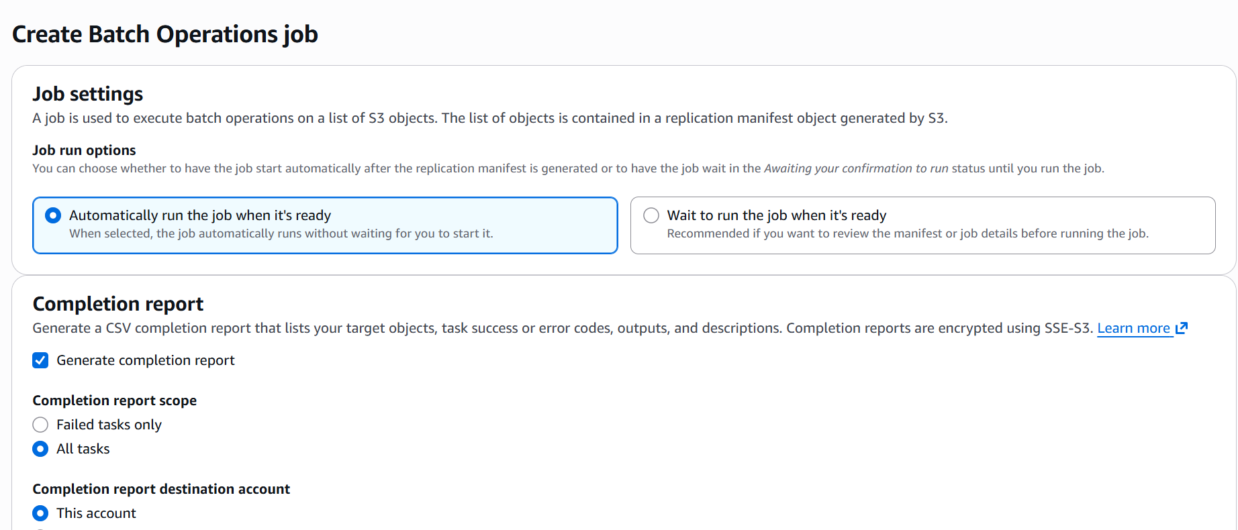

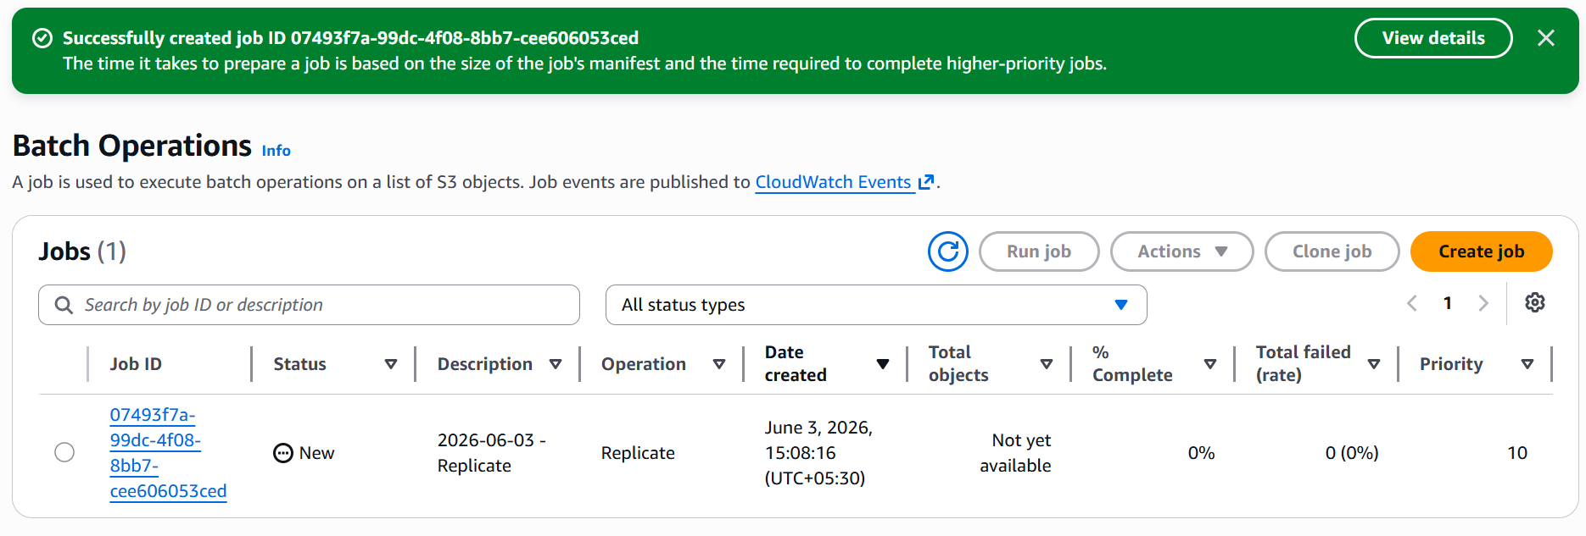

Now the enitre objects in my host bucket has been copied into destination bucket

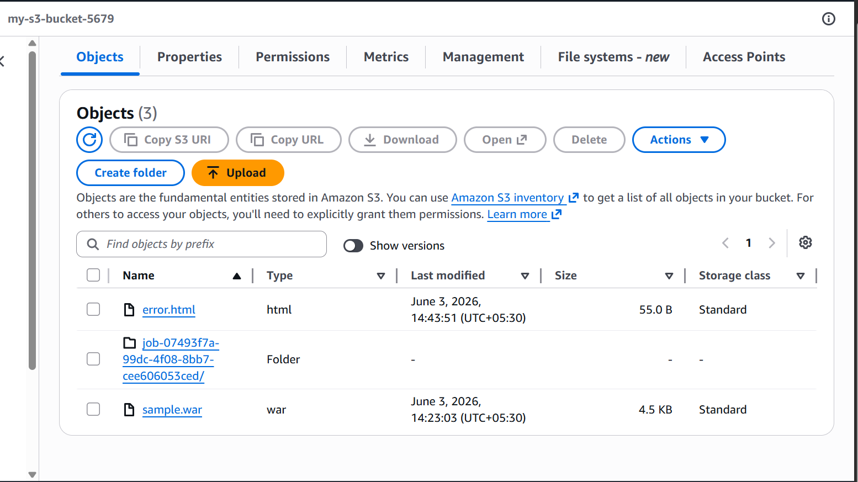

Now I have uploaded a new document in my host bucket and automatically the same file has been copied into other bucket in other region
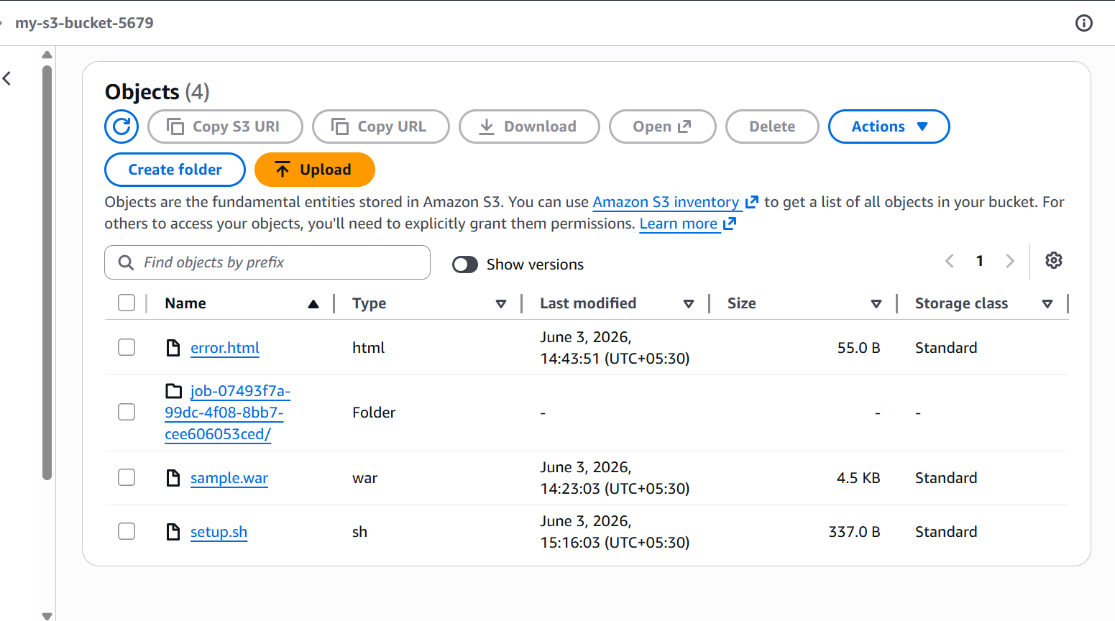

Configure a bucket policy so only the Admin user can see the objects of the S3 bucket

I will be creating a bucket policy so that admin user can see the objects of the s3 bucket
Creating a new user with admin access

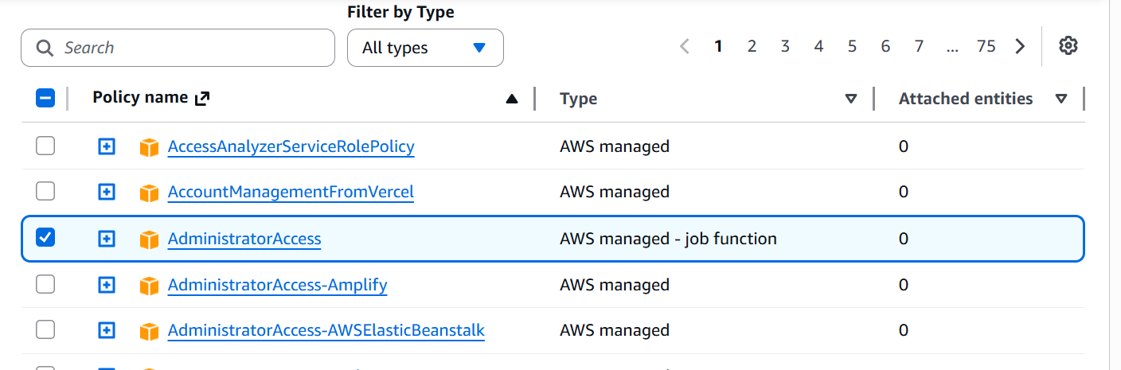

After creating a admin access user
I have given custom json for bucket policy
Now the admin-user has access objects in the s3

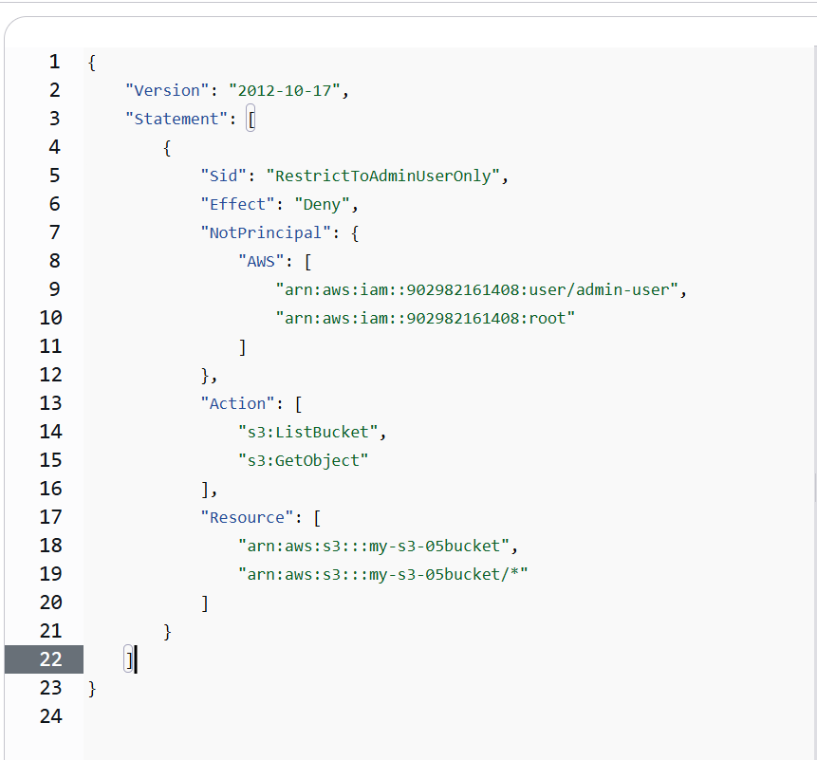

Now the admin user can see objects in s3 buckets
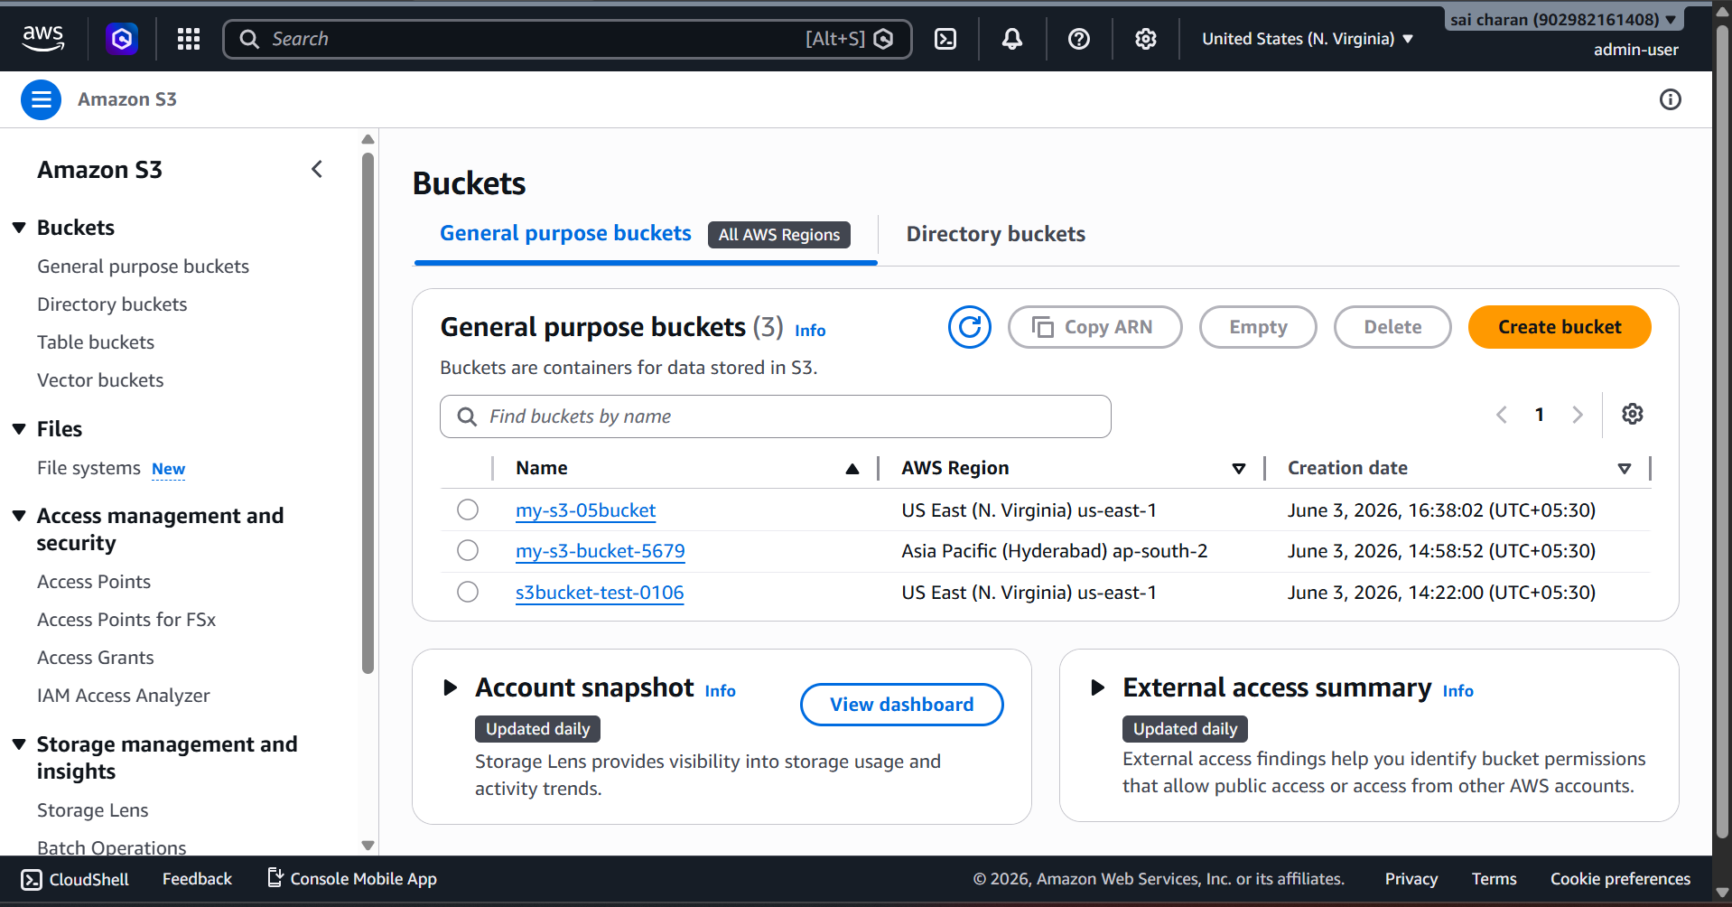

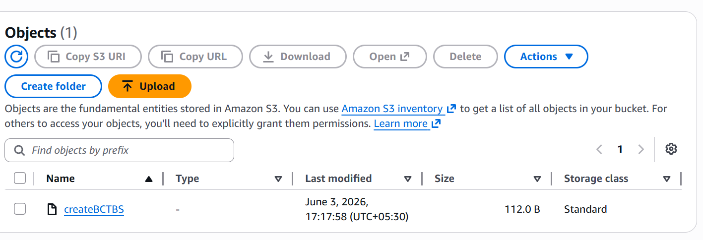

Set up lifecycle policies to automatically transition or delete objects based on specific criteria

I will be creating a life cycle for the objects that after some time it should move to specific class or gets deleted

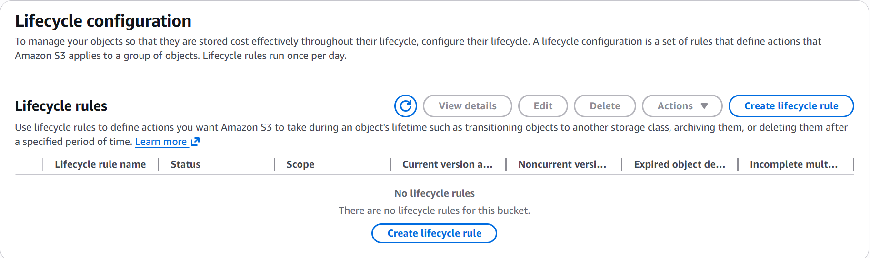

I need to select the maximum number of days that object should be in a storage class after that it will get moved to the mentioned storage class

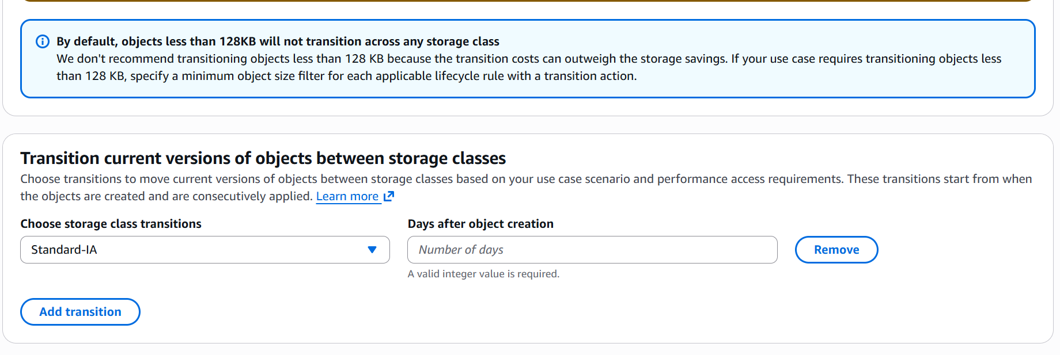

Objects that are 30 days old will be moved to standard and after moving to standard class after 60 day as it is moved to one-zone IA and for noncurrent objects after 30 days it is moved to standard IA class storage

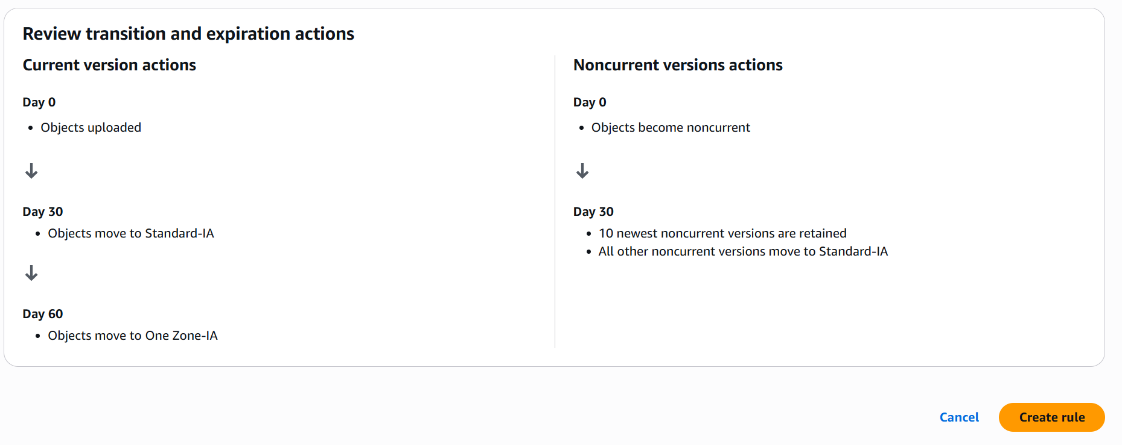

New lifecycle configuration has been created for my bucket

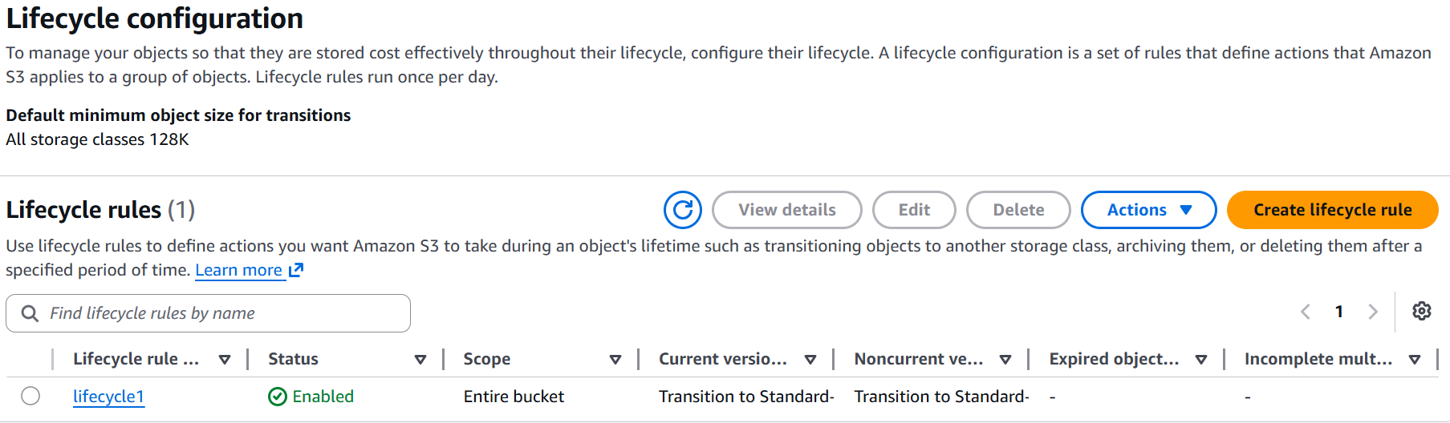

Push some objects to S3 using the AWS CLI

Using AWS CLI I will be pushing the objects into s3

Here I have used the below command and in bash I have configured my access and secretkey in aws configure.

aws s3 cp /path/to/local/file.txt s3://your-bucket-name/folder/

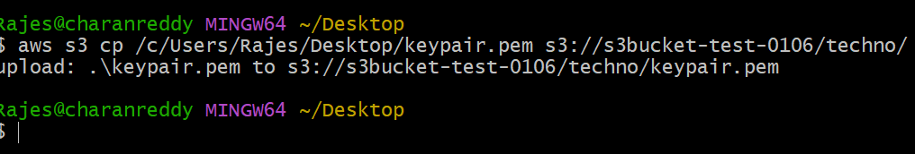

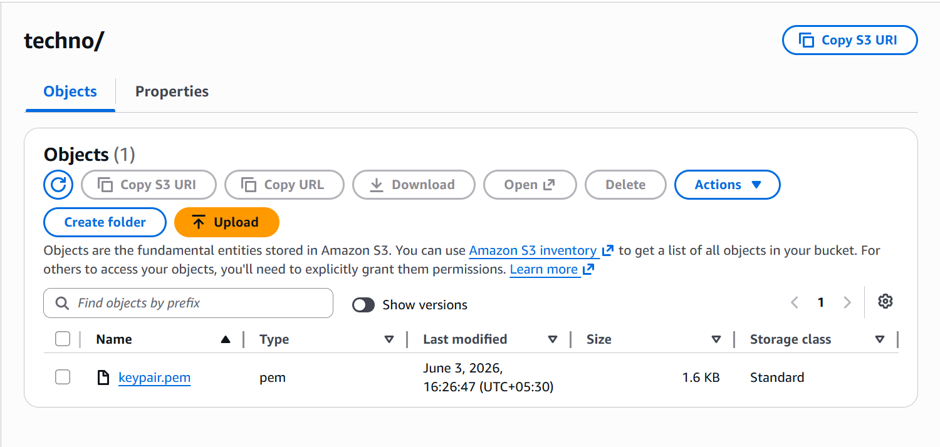

Write a Bash script to create an S3 bucket

To create a bucket = aws s3 mb s3://bucket

I have used above command in bash script to create a bucket in s3

Here new bucket has been created
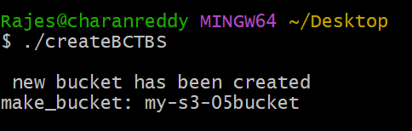

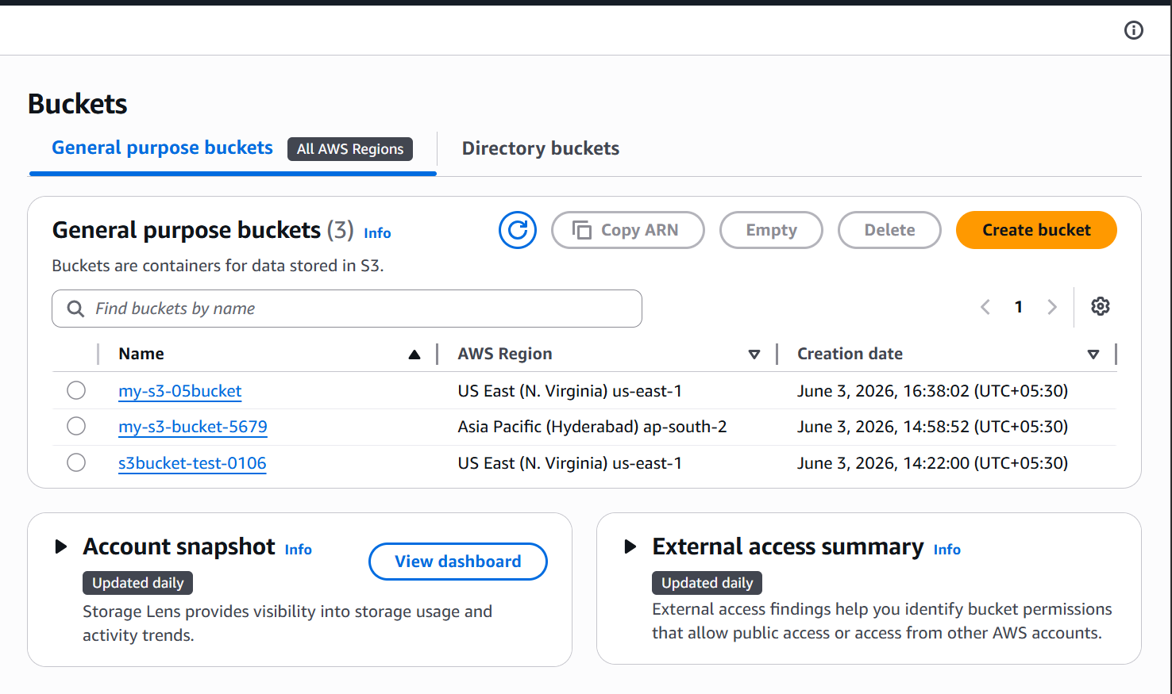

Upload a 1 GB file to S3 using the CLI

Uploading a 1gb file using cli to s3

I have used command aws s3 cp localpathtofile s3://bucketname/folder

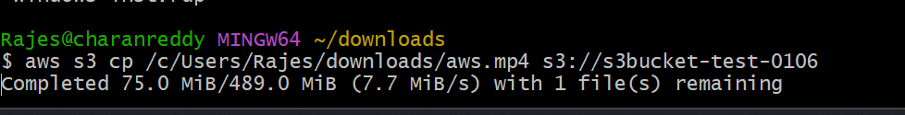

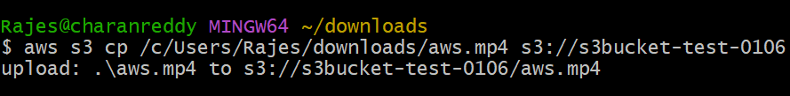

As I can see file has been uploaded and it harldy took 15sec
